**Use Case Of Online Doctor Appointment Booking**

**Use Case Name:** Online Appointment Booking System.

**Primary Actor:** Registered User of the App.

**Use Case Story:** This use case enables the registered user to book a doctor’s appointment online by selecting the date and time as per the user’s wish, and also pay the bill using online and offline methods, with offers on online payment and additional charges on offline payment. Moreover, after the visit to the hospital, the user can rate the doctor and can also view and download the bill.

**Trigger:** The user Searching for doctor using ‘rating’ dropdown filter on the Home/Search page.

**Pre-Condition: -** User should be a Registered user

**Post-Condition:** - User receives confirmation message

- User should be able to rate the doctor and view or download the bill onto the mobile device

**Primary Flow:**

**Title:** User is able to book an appointment online.

|  |  |
| --- | --- |
| **Actor Action** | **System Response** |
| 1. Registered User logs into the application | 1. System displays the **Home/Search** page |
| 1. User searches the doctor using the dropdown filters like Name, type and **rating**(new). (refer Wireframe 1) | 1. System displays the search result and shows the available doctors for that particular search (refer Wireframe 2) |
| 1. User chooses a doctor based on ratings and different factors and then clicks on the book appointment now command button of that particular doctor | 1. System navigates the user to the book an appointment page. |
| 1. User enters all the required data, selects the desired date & time for the appointment and then finally checks the checkbox (100rs deposit for confirming the appointment which is refundable) to proceed further and clicks on the procced to payment command button. (refer Wireframe 3)   Else,  If the user enters invalid details go to Alternate Flow 1(AF1) | 1. System navigates the user to the payment page (refer Wireframe 4) |
| 1. User selects any of the online payment method and clicks on it   Else,  If user selects to pay after visit via cash, to go Alternate Flow 2 (AF2) | 1. System sends the confirmation message to the user with 10 % discount on the total bill after visit + 1 free checkup (refer Wireframe 4) |
| 1. User then receives a message 2 hours before the appointment regarding the confirmation with Yes/No command button to confirm the appointment. (refer Wireframe 5) |  |
| 1. User clicks on Yes command button   Else,  If the user clicks on No command button, go to Exception Flow 1(EF1)  If the user doesn’t reply, go to Alternate Flow 3 (AF3) | 1. System confirms the appointment of that patient |
| 1. User visits the hospital on the appointed date and time |  |
| 1. User does the payment online with 10% discount on the bill, 100rs refunded back + 1 free checkup |  |
| 1. User then receives a notification on the application to rate the doctor and view or download the bill.   (refer Wireframe 6 & 7 (via cash)) |  |
| 1. User rates the doctor and also view/downloads the bill | 1. System sends the rating to the backend and also downloads the bill into the mobile device |

**Alternate Flow 1 (AF1):**

**Title:** If the user enters invalid details

|  |  |
| --- | --- |
| **Actor Action** | **System Response** |
| 1. If the user enters invalid details | System shows the following error messages:   * <Data Field> is a required field. Please enter a value for <Data Field> * Value for <Data Field> is invalid. Please enter a valid value for <Data Field> * <Full Name> is invalid. The Min Length is 3 Char and Max is 50 Char. * Please select an age. * Select a Gender. * <phone number> is invalid. Enter a 10 Digit Mobile number. * <Issue>Please Select an Issue. * <Address> is invalid. Address should be Min 10 Char and Max 100 Char long. * <Date> select a Date. * <Time>select a Time * Please confirm your ₹100 deposit to proceed with appointment booking. |
| 1. Go to step 7 of PF. |  |

**Alternate Flow 2 (AF2):**

**Title:** User selects to pay after visit via cash

|  |  |
| --- | --- |
| **Actor Action** | **System Response** |
| 1. User clicks on Pay after visit via cash command button | 1. System sends the confirmation message to the user with additional 50rs charge on total bill. |
| 1. Go to step 11 of PF. |  |

**Alternate Flow 3 (AF3):**

**Title:** If the user doesn’t reply

|  |  |
| --- | --- |
| **Actor Action** | **System Response** |
| 1. If user doesn’t reply to the message | 1. System initiates a call with that patient |
| 1. If the user receives the call   Else,  If the user doesn’t receive the call, go to Exception Flow 2 (EF2) | 1. System confirms the appointment |
| 1. Go to step 14 of PF |  |

**Exception Flow 1 (EF1):**

**Title:** If the user clicks on No command button

|  |  |
| --- | --- |
| **Actor Action** | **System Response** |
| 1. If the user clicks on No command button | 1. System auto cancels the appointment of that particular patient |

**Exception Flow 2 (EF2):**

**Title:** If the user doesn’t receive the call

|  |  |
| --- | --- |
| **Actor Action** | **System Response** |
| 1. If the user doesn’t receive the call | 2. System auto cancels the appointment of that particular patient. |

**Wireframe 1:**

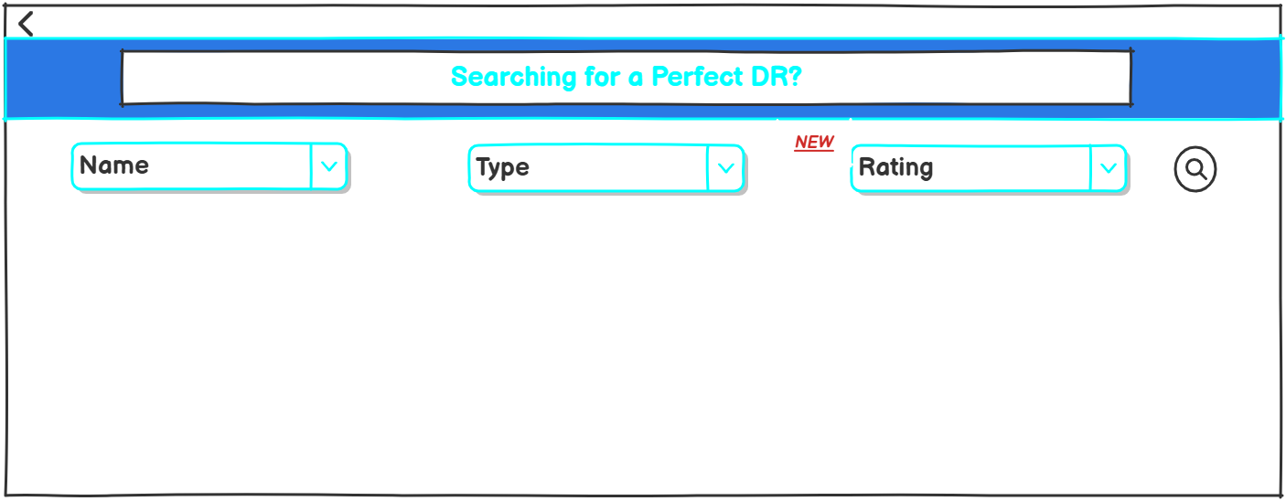

|  |  |  |  |  |  |  |  |
| --- | --- | --- | --- | --- | --- | --- | --- |
| **Sr. No.** | **Field Name** | **Field Type** | **Content** | **Required Field?** | **Min. Char.** | **Max Char.** | **Notes** |
| 1 | Rating | Dropdown | 1,1.5,2,2.5,3,3.5,4,4.5,5 | N/A | N/A | N/A | The dropdown should display different ratings, so that the user can filter and search for a doctor accordingly.  1 → Very Poor  2 → Poor  3 → Average  4 → Good  5 → Excellent |
| 2 | NEW | Label | N/A | N/A | N/A | N/A | The new tag/label describes that it is the new feature added to the application. |

**Wireframe 2:**

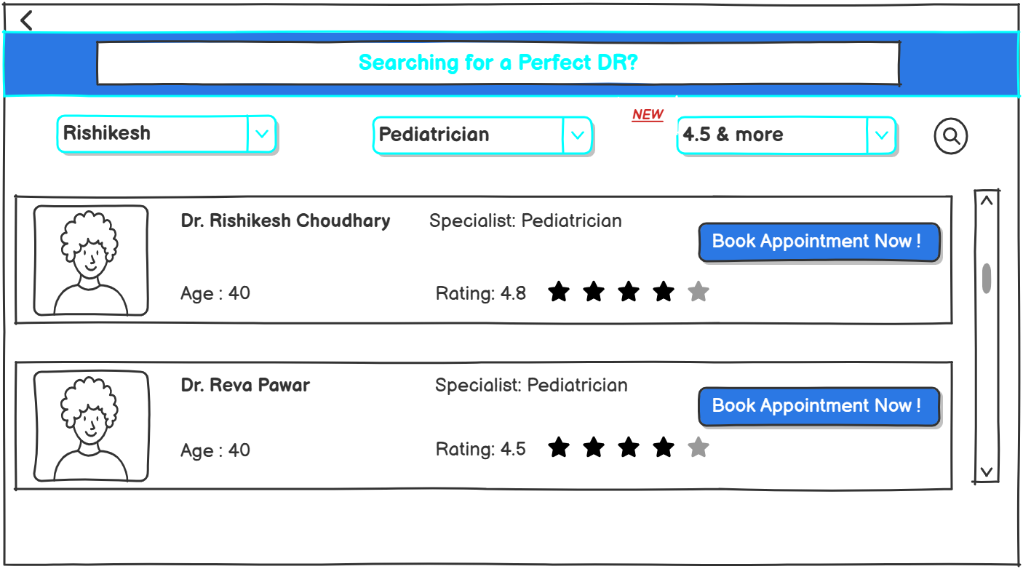

|  |  |  |  |  |  |  |  |
| --- | --- | --- | --- | --- | --- | --- | --- |
| **Sr. No.** | **Field Name** | **Field Type** | **Content** | **Required Field?** | **Min. Char.** | **Max Char.** | **Notes** |
| 1 | Doctor Name | Textbox | Dr. Rishikesh Choudhary  Dr. Reva Pawar | N/A | N/A | N/A | Display full name of the doctor |
| 2 | Doctor Photo | Image | N/A | N/A | N/A | N/A | Image of the doctor  Can be default avatar or uploaded image. |
| 3 | Age | Number | 40,50,60 | N/A | N/A | N/A | Displays the current age of the doctor |
| 4 | Specialist | Textbox | Pediatrician,general,etc | N/A | N/A | N/A | Displays the specialty field of the doctor |
| 5 | Rating | Number | 4, 4.5, 4.9, etc | N/A | N/A | N/A | The rating should include the average of the ratings given by the real patients also with stars for visual appeal. |
| 6 | Book Appointment Now | Command Button | N/A | N/A | N/A | N/A | On click, displays the Appointment booking page. |

**Wireframe 3:**

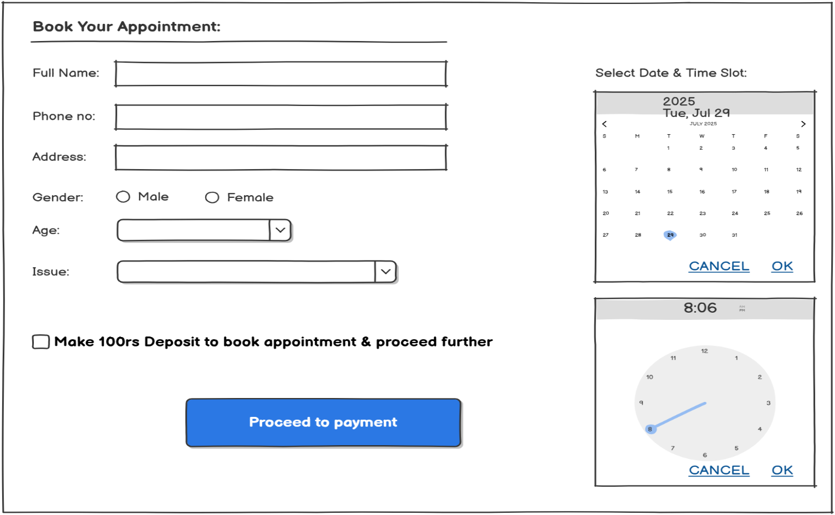

|  |  |  |  |  |  |  |  |
| --- | --- | --- | --- | --- | --- | --- | --- |
| **Sr. No.** | **Field Name** | **Field Type** | **Content** | **Required Field?** | **Min. Char.** | **Max Char.** | **Notes** |
| 1 | Full Name | Textbox | User's full name | Yes | 3 | 50 | Accept only alphabetic characters |
| 2 | Phone Number | Textbox | 10-digit mobile number(numeric) | Yes | 10 | 10 | 10 digit numeric format |
| 3 | Address | Multiline Textbox | Alphanumeric | Yes | 10 | 100 | Can be multiline |
| 4 | Gender | Radio Button | Male, Female | Yes | N/A | N/A | One option must be selected |
| 5 | Age | Dropdown | 1–100 | Yes | 1 | 3 | Only numeric options |
| 6 | Issue | Dropdown | (Fever, Diabetes, Chest Pain, etc.) | Yes | 3 | 50 | Populated from list of common medical issues |
| 7 | Date Picker | Calendar Widget | Select date (e.g., July 29, 2025) | Yes | N/A | N/A | Should not allow past dates  Should strike out the date which are not available for that particular patient |
| 8 | Time Slot | Clock Widget | Select time (e.g., 8:06 AM) | Yes | N/A | N/A | Show only available slots, no double booking |
| 9 | ₹100 Deposit Checkbox | Checkbox | "Make ₹100 deposit..." | Yes | N/A | N/A | Must be checked before enabling "Proceed to Payment" button |
| 10 | Proceed to Payment | Command Button | “Proceed to Payment” | Yes | N/A | N/A | On click, triggers the payment gateway |

**Wireframe 4:**

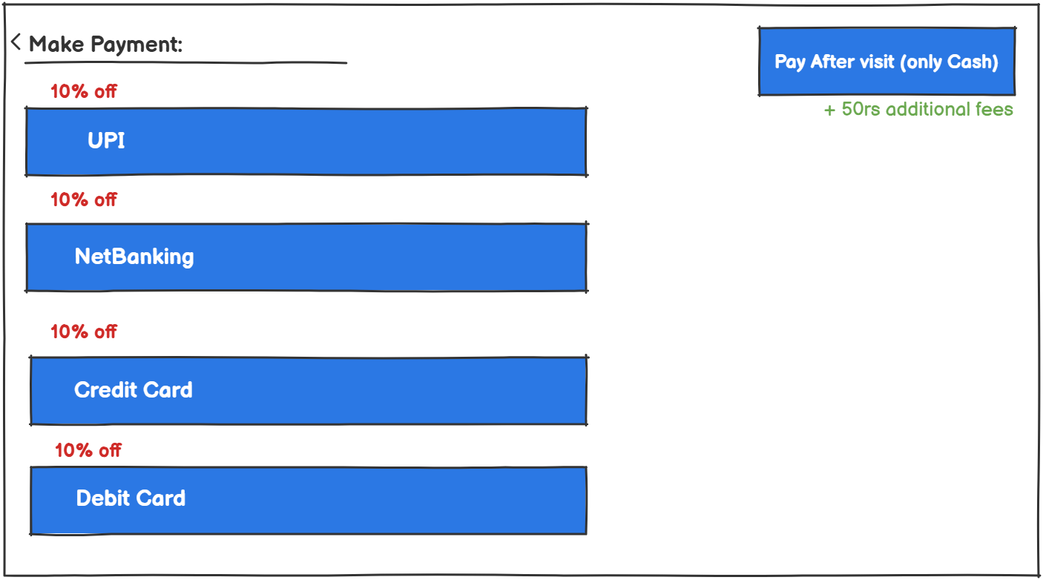

|  |  |  |  |  |  |  |  |
| --- | --- | --- | --- | --- | --- | --- | --- |
| Sr. No. | Field Name | Field Type | Content | Required Field? | Min. Char. | Max Char. | Notes |
| 1 | Discount Message | Label | "10% off" | No | N/A | N/A | Shown for online payment methods only. |
| 2 | Cash Payment Note | Label | "+50rs additional fees" | No | N/A | N/A | Displayed only if "Pay After Visit" (Cash) is selected.  Also on Cash payment charge 50rs extra. |

**Wireframe 5:**

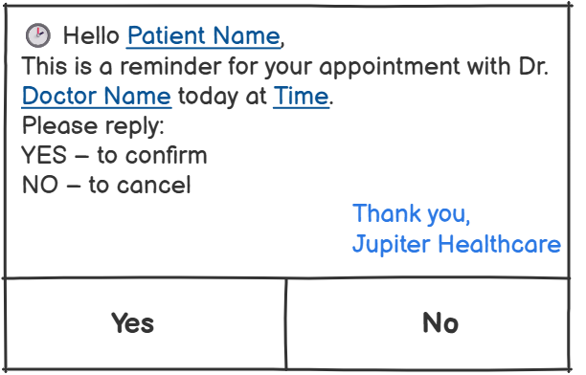

|  |  |  |  |  |  |  |  |
| --- | --- | --- | --- | --- | --- | --- | --- |
| **Sr. No.** | **Field Name** | **Field Type** | **Content** | **Required Field?** | **Min. Char.** | **Max Char.** | **Notes** |
| 1 | Patient Name | Dynamic Text | John Doe | Yes | 1 | 100 | Pulled from patient database based on appointment ID |
| 2 | Doctor Name | Dynamic Text | Dr. Rakesh Mehta | Yes | 1 | 100 | Pulled from doctor database linked to the appointment |
| 3 | Time | Dynamic Text | 10:30 AM | Yes | 5 | 10 | Appointment time to be inserted dynamically linked to the appointment |
| 4 | Reminder Message | Static Text | “This is a reminder…” | Yes | N/A | N/A | Fixed message text |
| 5 | Reply Options | Command Button | YES, NO | Yes | N/A | N/A | Clicking YES or NO sends response to backend |

**Wireframe 6: Online Paid users will receive this!**

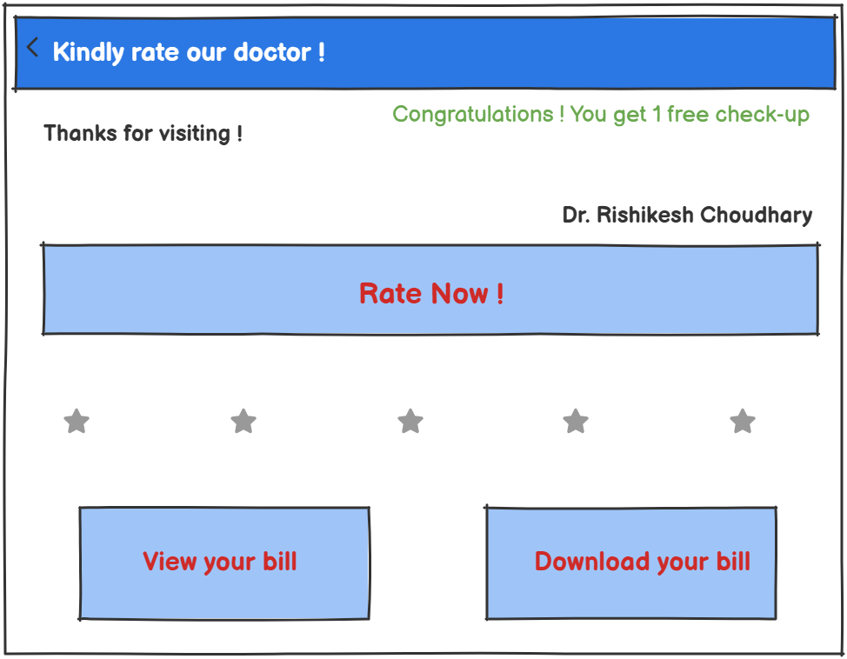

**Wireframe 7: Offline/Cash paid users will receive this!**

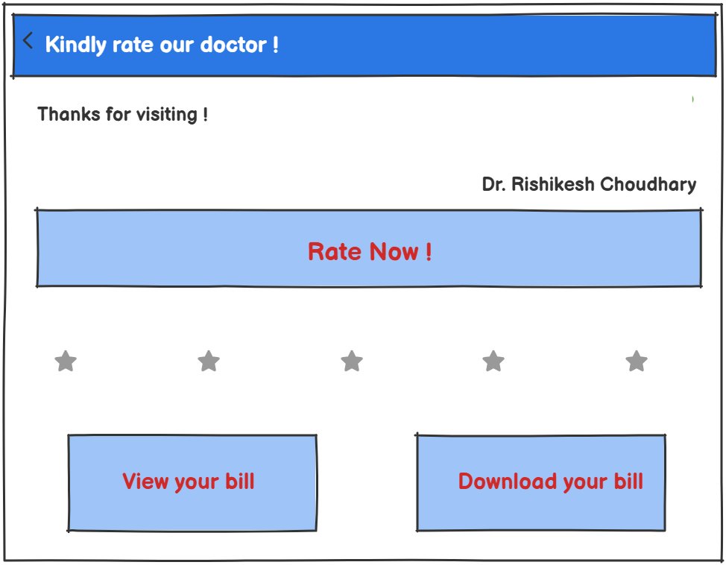

|  |  |  |  |  |  |  |  |
| --- | --- | --- | --- | --- | --- | --- | --- |
| Sr. No. | Field Name | Field Type | Content | Required Field? | Min. Char. | Max Char. | Notes |
| 1 | Doctor Name | Text | Dr. Rishikesh Choudhary | Yes | 3 | 50 | Displayed automatically based on appointment. |
| 2 | Feedback Message | Label | "Thanks for visiting!" | No | 5 | 100 | Can be a dynamic or static message. |
| 3 | Rating Value | Star | 1 to 5 stars | Yes | N/A | N/A | Patient selects from 1–5 stars (mapped as numeric). |
| 4 | Free Check-up | Conditional Text | "You get 1 free check-up!" | No | N/A | N/A | Shown only if patient is eligible (after bill paid online). |
| 5 | Rate Now | Command button | "Rate Now!" | Yes | N/A | N/A | On click, submits the users rating |
| 6 | View Bill Button | Command Button | "View your bill" | Yes | N/A | N/A | Opens bill in-app |
| 7 | Download Bill Button | Command Button | "Download your bill" | Yes | N/A | N/A | Downloads bill as PDF to user’s device. |